Introduction to Pivot Tables
A PivotTable is tool that creates a cross tabulation (cross tab) analysis, showing the joint distribution of two or more variables.
This analysis is carried out on data that is presented in the form of a list or database, where each column has a heading or field name.

Unit objectives
By the end of this unit, you will be able to:
- Create a PivotTable.
- Change the display of PivotTable data using Field Settings.

Creating a simple pivot table
To create a PivotTable from an Excel list/database:
- Select a cell within the database
- Click on the Data menu
- Select PivotTable and PivotChart Report
- Select the relevant options (MS Office database and PivotTable) and click Next
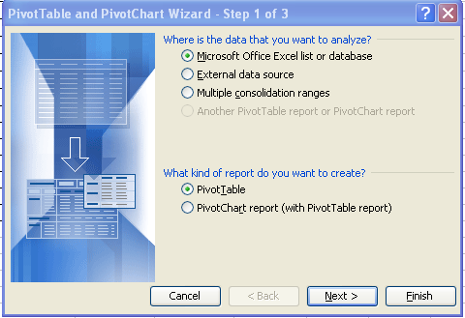

- Check the data range is correct, and click Next
(Note if a cell within the database was selected before starting the wizard, this will automatically select the current region of that cell)
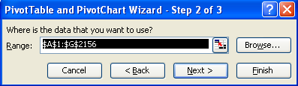

- Choose to put the PivotTable in a new or existing sheet and click Next
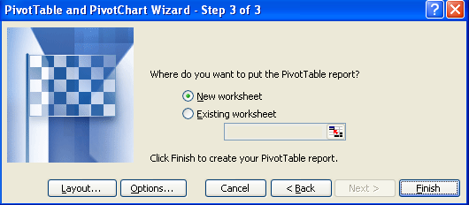

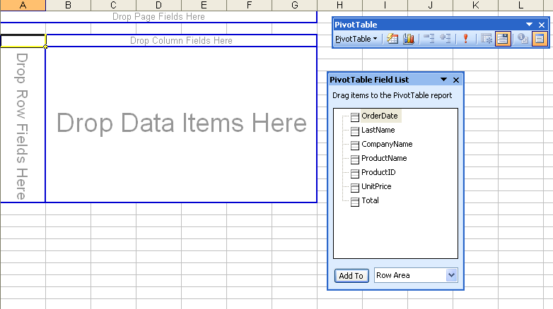
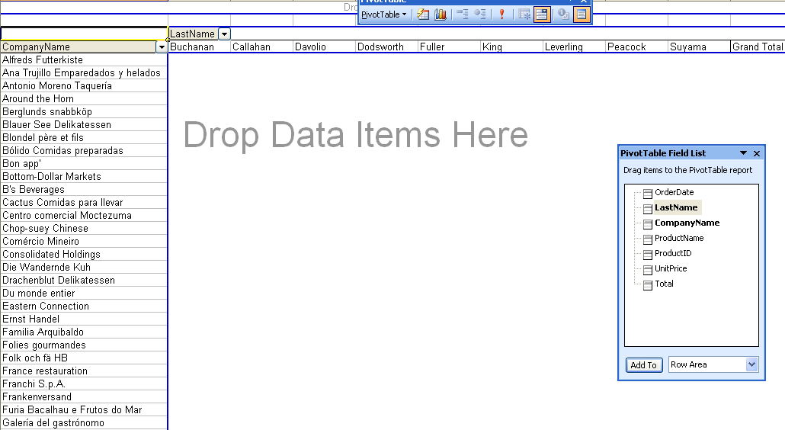
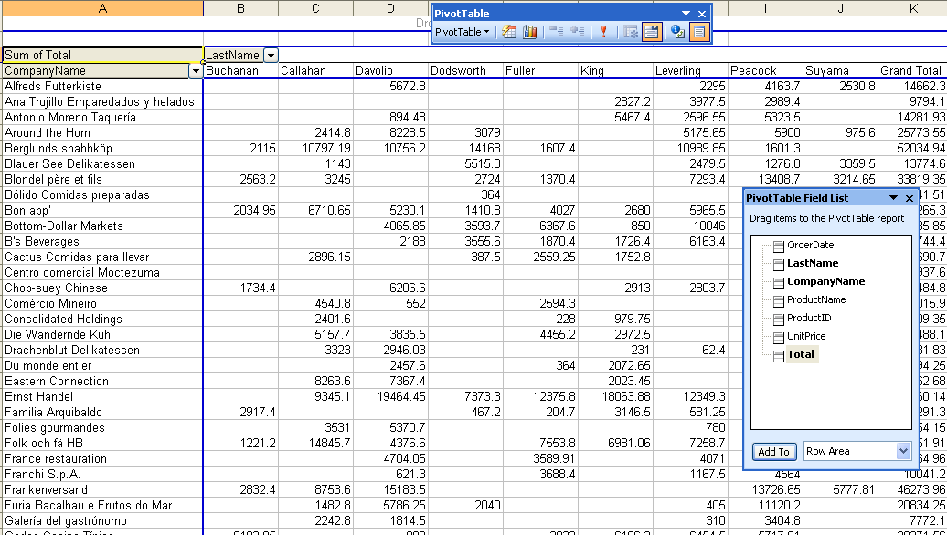
- The PivotTable areas will then appear in the workbook.
Simply drag and drop fields from the PivotTable Field List into the Column, Row, Page and Data Items areas to analyse the data.
1

2

3

Formatting data items
The data items area will initially be based on the sum or count functions depending on the context.

Changing the function
To change the function used in the data items area:
- Click on the Format Field button on the PivotTable toolbar
- Select the required function under Summarize by
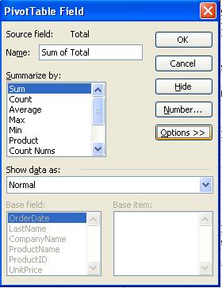

Using the Number button
Clicking on the Number button in the PivotTable Field dialogue box opens the Format Cells dialog box, so that PivotTable items can be formatted as required.
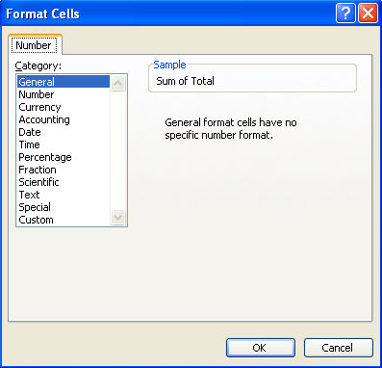

Unit heading Practice Activity
- Instructions are numbered
- Subpoints of instructions are bulleted
- x

Online support forum and knowledge base

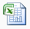
www.microsofttraining.net/forum
Visit our forum to have your questions answered by our Microsoft qualified trainers.

